**Code:**

void setup()

{

pinMode(11, OUTPUT);

pinMode(10, OUTPUT);

pinMode(9, OUTPUT);

}

void loop()

{

//violet

analogWrite(11, 76);

analogWrite(10, 0);

analogWrite(9, 153);

delay(1000);

//blue

analogWrite(11, 51);

analogWrite(10, 51);

analogWrite(9, 255);

delay(1000);

//sky blue

analogWrite(11, 51);

analogWrite(10, 102);

analogWrite(9, 255);

delay(1000);

//green

analogWrite(11, 0);

analogWrite(10, 102);

analogWrite(9, 0);

delay(1000);

//yellow

analogWrite(11, 255);

analogWrite(10, 255);

analogWrite(9, 0);

delay(1000);

//orange

analogWrite(11, 255);

analogWrite(10, 128);

analogWrite(9, 0);

delay(1000);

//red

analogWrite(11, 153);

analogWrite(10, 0);

analogWrite(9, 0);

delay(1000); // Delay a little bit to improve simulation performance

}

**Circuite:**

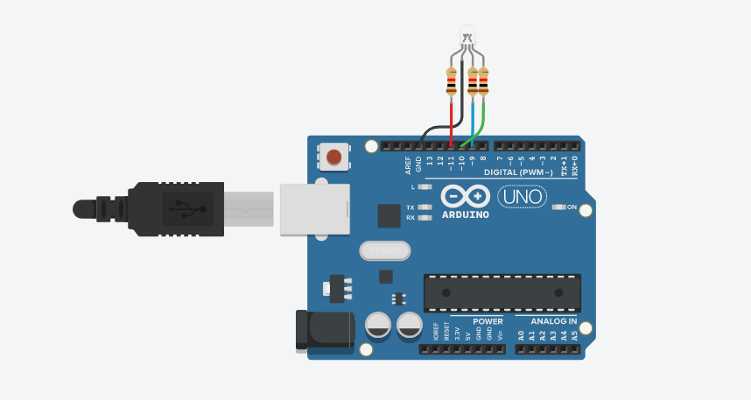

**Work Principle:**

led light will show all the color of rainbow one by one